 | Sukkur IBA University
Department of Computer Science

Course Title: Applied Physics
Spring, 2024
Tasks
Task01: Solve the following circuit using Current Divider Rule.
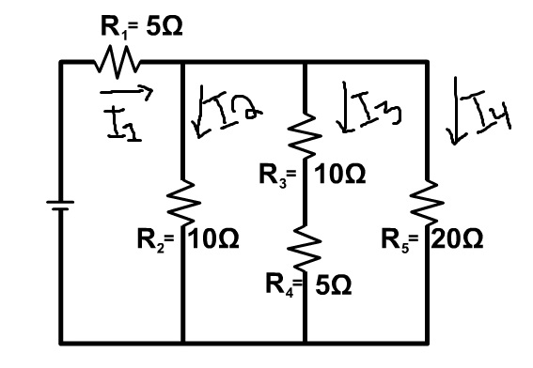
Find I₁, I₂, I₃, and I₄
Task02: Solve the following circuit using Voltage Divider Rule.
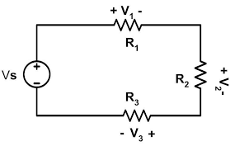
Find V₁, V₂, and V₃.

